ORDERING
KS1 – 2001 Paper
1.
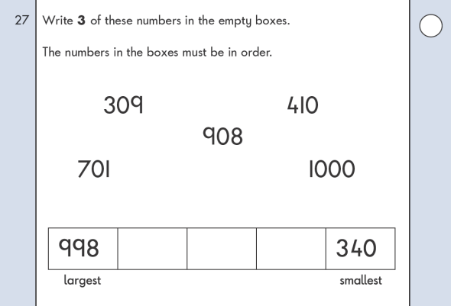
KS1 – 2002 Paper
2.

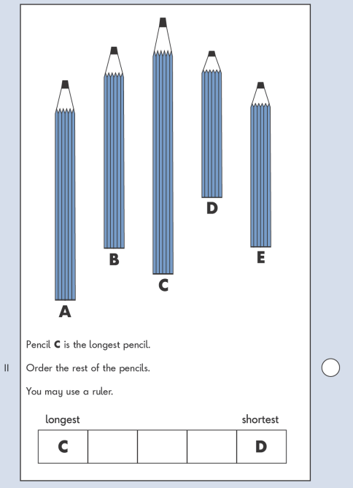
KS1 – 2003 Paper 1
3.

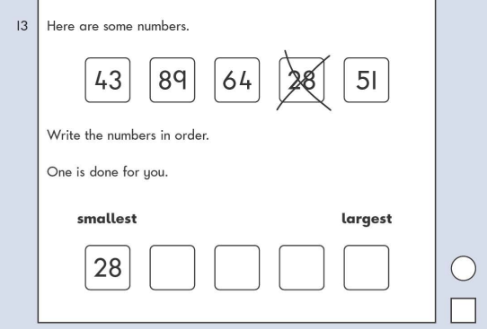
KS1 – 2003 Paper 2
4.

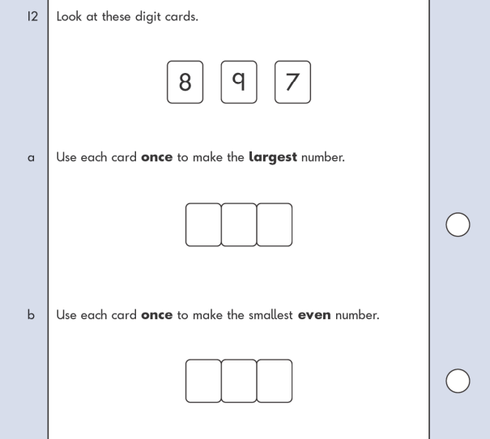
KS1 – 2004 Paper 1
5.

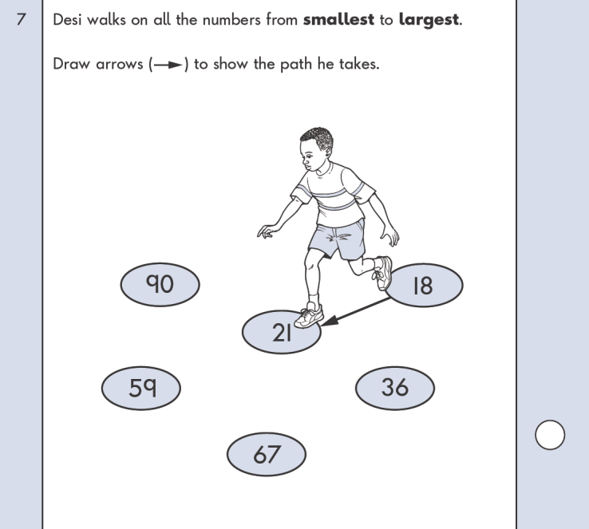
KS1 – 2004 Paper 2
6.

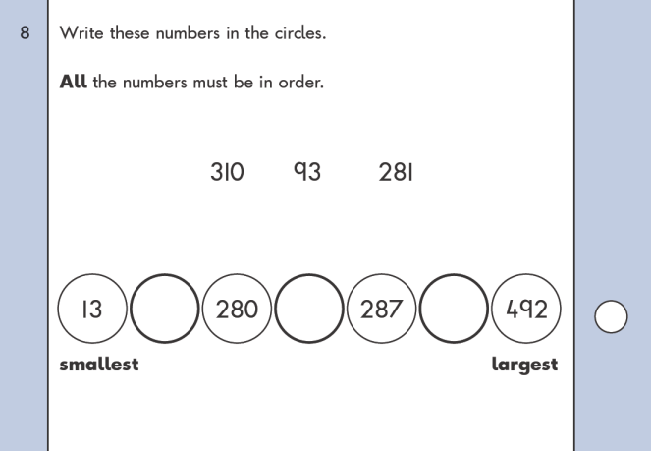
KS1 – 2005 Paper 1
7.
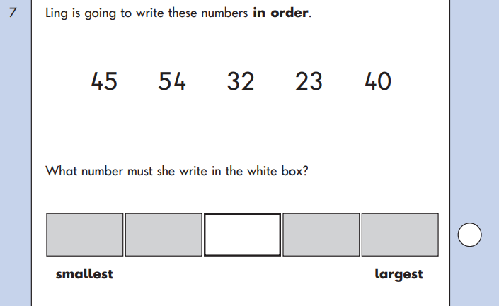
KS1 – 2005 Paper 2
8.
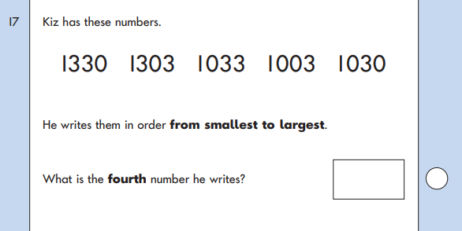
KS1 – 2017 Paper – Reasoning
9.
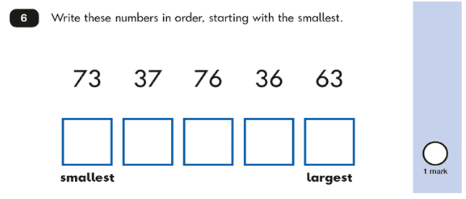

KS1 – 2022 Paper – Reasoning
10.
